Notes 6.2: Graphing Cube Root and Cubic Functions
Algebra 2

Cube Root Parent Function Cubic Parent Function

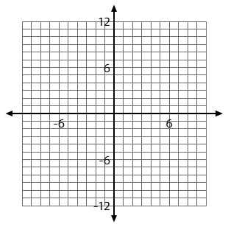
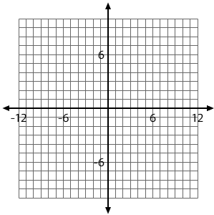

Characteristics
x-intercept:
y-intercept:
Domain:
Range:
Symmetry:
Characteristics
x-intercept:
y-intercept:
Domain:
Range:
Symmetry:

Find the x-intercept and y-intercept of the following functions.

1. $f(x)=\sqrt[3]{x+8}-2$ 2. $f(x)={\left(x-3\right)}^{3}+8$

3. $f(x)=\sqrt[3]{x-1}+3$ 4. $f(x)=-2{\left(x+1\right)}^{3}+16$

Basic Form of Transformed Equations:
Cube Root Transformed Function Cubic Transformed Function

$f(x)=a\sqrt[3]{b(x-h)}+k$ $f(x)={a\left(b(x-h)\right)}^{3}+k$

OR
$f(x)=a{\left(b(x-h)\right)}^{\frac{1}{3}}+k$

Steps to Graphing and providing information
1. List transformations
2. Identify the vertex
3. Fill out a table
4. Plot points from table onto graph paper
5. Identify Domain and Range, x and y intercepts when appropriate

Identify Transformations
$f(x)=a\sqrt[3]{b(x-h)}+k$ OR $f(x)={a\left(b(x-h)\right)}^{3}+k$

a = ________________________________________________________________

b = ________________________________________________________________

h = ________________________________________________________________

k = ________________________________________________________________

Identify the vertex
This can be identified by right/left shift and up/down shift.
Example:$f(x)=-2\sqrt[3]{-x-3}+5$

Fill in the table and plot points on graph paper
$y=\sqrt[3]{x}$ $y=-2\sqrt[3]{x}$ $y=\sqrt[3]{-\frac{1}{2}x}$ $y=\frac{1}{2}\sqrt[3]{-3x}$ Parent Function

$x$ | $\sqrt[3]{x}$

Example 1: Example 2:


$f(x)=\sqrt[3]{-x}+1$ $f(x)=2\sqrt[3]{3x+18}-4$

Characteristics
transformations:

x-intercept:
y-intercept:
Domain:
Range:

Characteristics
transformations:

x-intercept:
y-intercept:
Domain:
Range:


Example 3: $f(x)=-\sqrt[3]{-2x-4}+1$
Characteristics
transformations:

x-intercept:
y-intercept:
Domain:
Range:


Example 4:
$f(x)=-\frac{1}{2}\sqrt[3]{x-1}-3$
Characteristics
transformations:

x-intercept:
y-intercept:
Domain:
Range:

Example 5: Example 6:


$f(x)=(-x)^{3}+1$ $f(x)=2(3x+18)^{3}-4$

Characteristics
transformations:

x-intercept:
y-intercept:
Domain:
Range:

Characteristics
transformations:

x-intercept:
y-intercept:
Domain:
Range:


Example 7: $f(x)=-(-2x-4)^{3}+1$
Characteristics
transformations:

x-intercept:
y-intercept:
Domain:
Range:

Example 8:

$f(x)=-\frac{1}{2}(x-1)^{3}-3$
Characteristics
transformations:

x-intercept:
y-intercept:
Domain:
Range:

